Your Name and Country: . Email Address: .
Name of Activity or Game: . Free Play Structured Play
Country of Origin and Cultural Links: .
Areas of Learning During Play: Cultural Identity Language Math Science Social Skills Problem Solving Creativity Skill Building Others: .
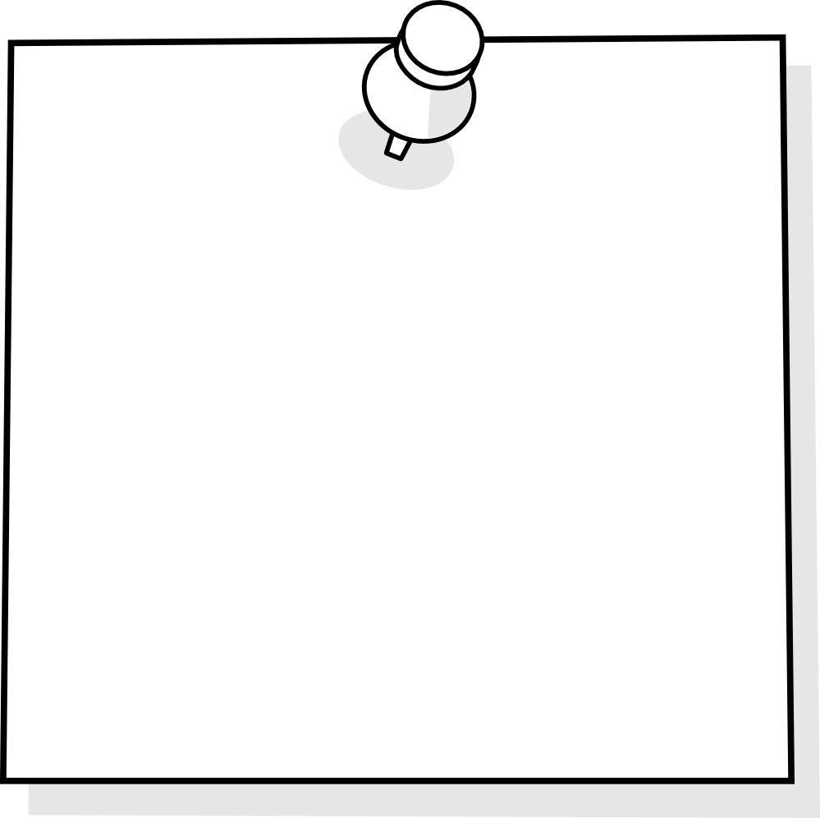

Materials Needed
Instructions

Indoors or Outdoors
”Tell me.. Show me about…”

Other Notes
Lea
Adult Role

