Your Support Will Help Children
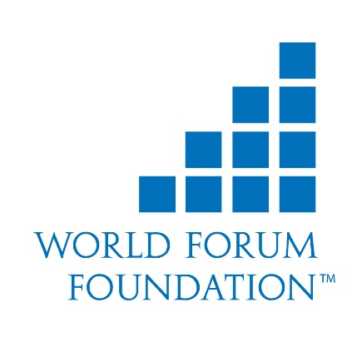

Date:
Name
Address
City, State
Country

Dear _________________,

I am writing to ask for your support so that I can better support and serve children.

More than ever it is vital that today’s young children grow and develop in ways that support positive educational outcomes while also fostering an appreciation for the diversity of our global society. Toward that end, I would like to attend the 2019 World Forum on Early Care and Education. The World Forum will bring together 800 early childhood educators and advocates from over 90 countries to share ideas and innovations in educating the world’s children. As a delegate I will gain inspiration, support, and practical solutions to enhance my work with children and families.

The 2019 World Forum will be held in Vancouver, British Columbia, Canada from April 20 – 23, 2021. It is organized by the World Forum Foundation, a tax-exempt nonprofit organization that over the past 19 years has organized 52 forums in 34 countries attended by over 10,000 early childhood professionals from 151 countries.

Delegates are asked to raise their own funds to pay for their attendance at the event. This is why I am contacting your organization.

[Provide a brief description here of what support you are requesting and how you would benefit from attending the 2021 World Forum.]

We are hopeful that you will be able to [fill in your specific request here.]. Thank you, on behalf of the children I serve, the next generation of global citizens.

Sincerely,

